THE MULTIPLE AXIS ELLIPSOIDS AS REFERENCE SURFACES FOR MAPPING OF SMALL CELESTIAL BODIES

Maxim V. Nyrtsov,
Lev M. Bugaevsky
Moscow State University of Geodesy and Cartography (MIIGAiK), Moscow, Russia, 103064, Gorokhovsky per., 4
e-mail: kartfak@miigaik.ru

Philip J. Stooke
University of Western Ontario, Department of Geography, London, Ontario, Canada, N6A 5C2
e-mail: pjstooke@uwo.ca

Abstract. Nowadays the purposes of exploration of space are study of the solar system and deep space objects, discovery of new celestial bodies, their detailed exploration and transfer of this information to the Earth. For celestial bodies whose shapes are different from a sphere or ellipsoid it is possible to use the well known triaxial ellipsoid as a reference surface which is mathematically calculated and shows the elongated figure of a body. But many small bodies such as satellites, asteroids or nuclei of comets have more complex figures than a triaxial ellipsoid can show. For this purpose we can consider map projections of non-spherical bodies which display the figure of the body clearly and geographically correct, but the calculation of distortions in those projections is a very complicated task. Therefore directed by two purposes - to keep the possibility of calculation of distortions and to keep geographical accuracy - we suggest the use of multiple axis ellipsoids as reference surfaces.

In accordance of investigations of Academician Lyapunov A. N.: “The celestial bodies have most stable shapes close to tri-axial ellipsoid”. Traditionally most non-spherical bodies are approximated by a triaxial ellipsoid which is mathematically calculated and shows the non-spherical figure of the body. At the same time many small bodies such as satellites, asteroids or nuclei of comets have more complex figures than a triaxial ellipsoid can show. Moreover in most cases the bodies approximated by triaxial ellipsoids have shapes elongated by different amounts in different directions. For this purpose we can consider map projections of non-spherical bodies which display the figure of the body clearly and geographically correct, but the calculation of distortions in those projections is a very complicated task. Therefore directed by two purposes - to keep the possibility of calculation of distortions and to keep geographical accuracy - we suggest the use of multiple axis ellipsoids as reference surfaces.

A figure with an infinite number of equatorial semi-axes may give the complete representation of a body under one term. The term is: “the altitude of the physical surface above the reference surface is calculated along the first vertical N at every point of the surface”. The use of such a figure as a reference surface is a very complicated task. But if we simplify the process by taking only two polar and two equatorial or two polar and four equatorial semi-axes, then this multiple axis ellipsoid will be close to the shape of the body and retains the possibility of calculating distortions while keeping geographical accuracy.

Thus in order to solve the problem of mapping small celestial bodies it is necessary to consider the development of a mathematically described figure which will approximate the real shape of the body more closely than a triaxial ellipsoid does.

Russian approach

We consider the theoretical and methodological aspects of development of “four and six axes” ellipsoids which have different values of semi axes.
The equations of relation of spatial coordinates X, Y, Z and geodetic coordinates in papers of Krasovsky F. N. and Bespalov N. A. are described as follows:

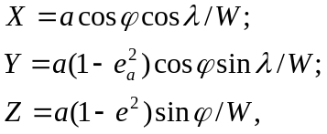 (1)
where 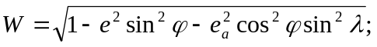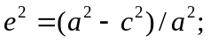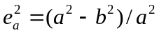,
e – first polar eccentricity, e_{a} - first equatorial eccentricity.

To take into account the ideas expressed above, we modify these equations by entering four or six semi axes. The “four-axes” ellipsoid has two polar and two equatorial semiaxes. Two equatorial semi axes will be a, b, and polar semi axes - c, c' (Fig. 1). All four quadrants of the ellipsoid will have equatorial semiaxes equal to a and b, but the north and south polar semi axes will be different. For the southern hemisphere the fourth semi axis c' enters into the equations in contrast to the triaxial ellipsoid.

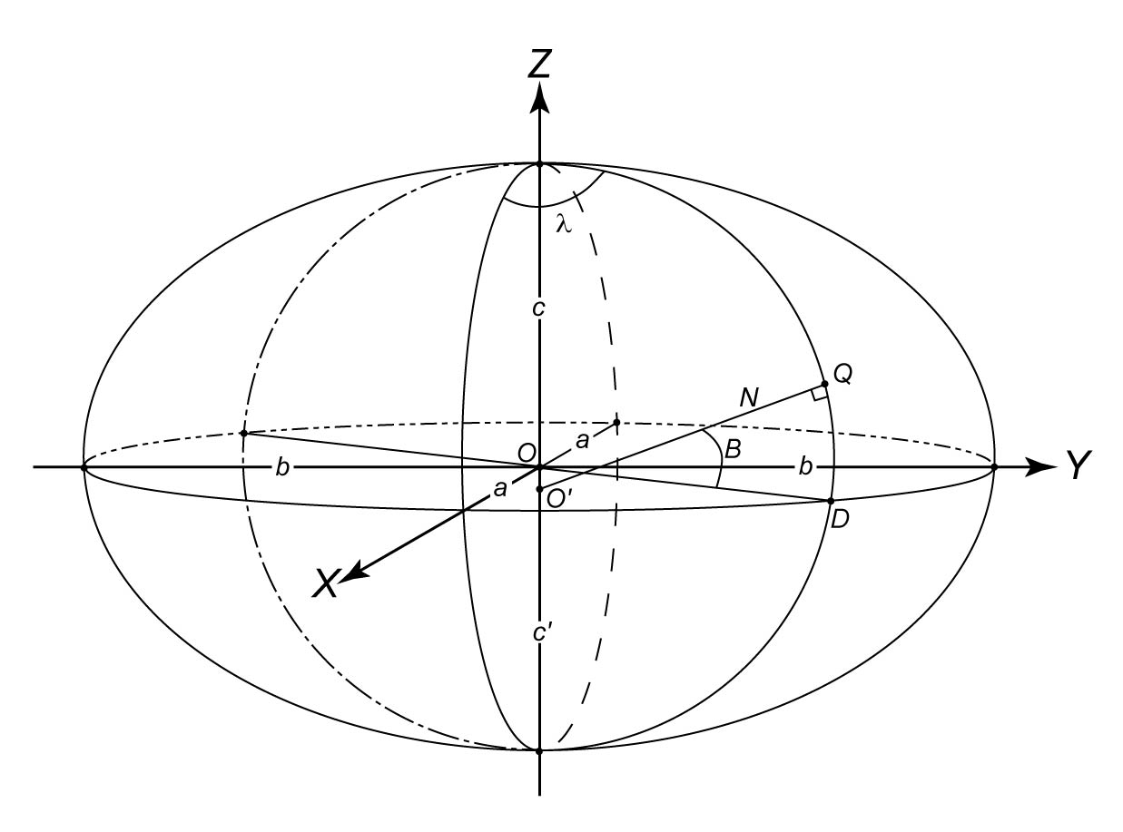
Figure 1 “Four-axis ellipsoid”

“Six-axis” ellipsoid takes its name from two polar and four equatorial semi axes. We name them as follows. The four equatorial semi axes are a, a', b, b', and the two polar semi axes are c, c'. The equatorial semi axes change their value from a to a' and from b to b'. The semi axis in the southern hemisphere is c' and the semi axis in the northern hemisphere is c (Fig. 2).
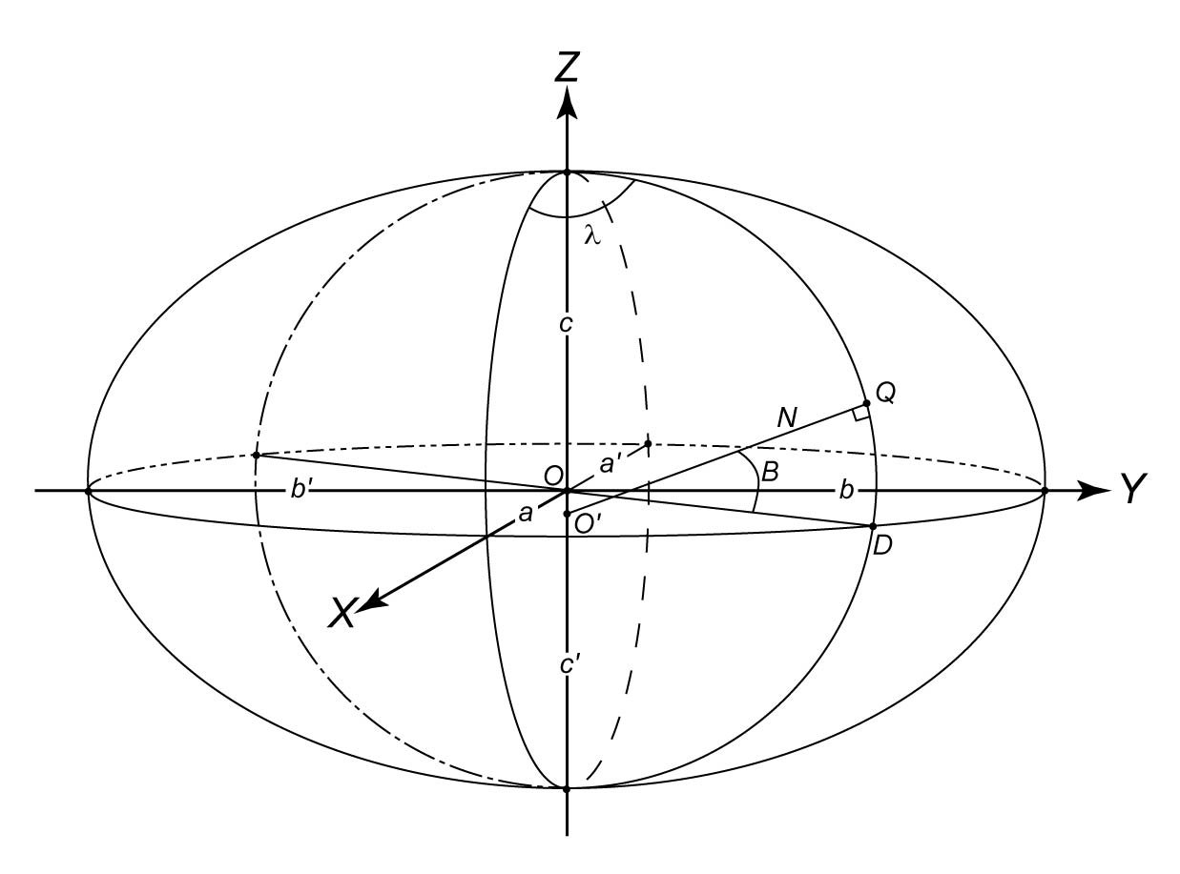
Figure 2 “Six-axis ellipsoid”

Thus we have eight sections (octants) of the multiple axis ellipsoid. Every octant has its own combination of semi axes (Table 1).
Table 1
Quarter number | Coordinates | Semi axes
East hemisphere (for bodies with direct rotation)
I-1 | ϕ changes from -90° to 0  λ changes from 0 to 90° | a, b, c'
I-2 | ϕ changes from 0 to 90°  λ changes from 0 to 90° | a, b, c
II-1 | ϕ changes from -90° to 0  λ changes from 90° to 180° | b, a', c'
II-2 | ϕ changes from 0 to 90°  λ changes from 90° to 180° | b, a', c
West hemisphere (for bodies with reverse rotation)
III-1 | ϕ changes from -90° to 0  λ changes from 180° to 270° | a', b', c'
III-2 | ϕ changes from 0 to 90°  λ changes from 180° to 270° | a', b', c
IV-1 | ϕ changes from -90° to 0  λ changes from от 270° to 360° | b', a, c'
IV-2 | ϕ changes from 0 to 90°  λ changes from 270° to 360° | b', a, c
For every octant the equations (1) will be individual. For example, for octant I-1 semi axes are a, b, c', and equations:
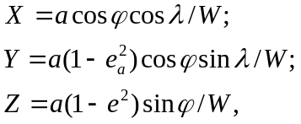 (2)
where 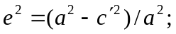
For octant III-2, where semi axes – a', b', c equations (1) will be next:

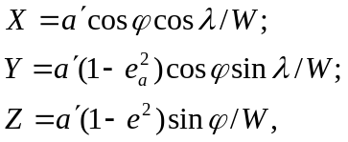 (3)
where 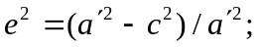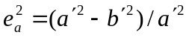
The multiple axis ellipsoid consisting of six semi axes can be shown as in Figure 3.
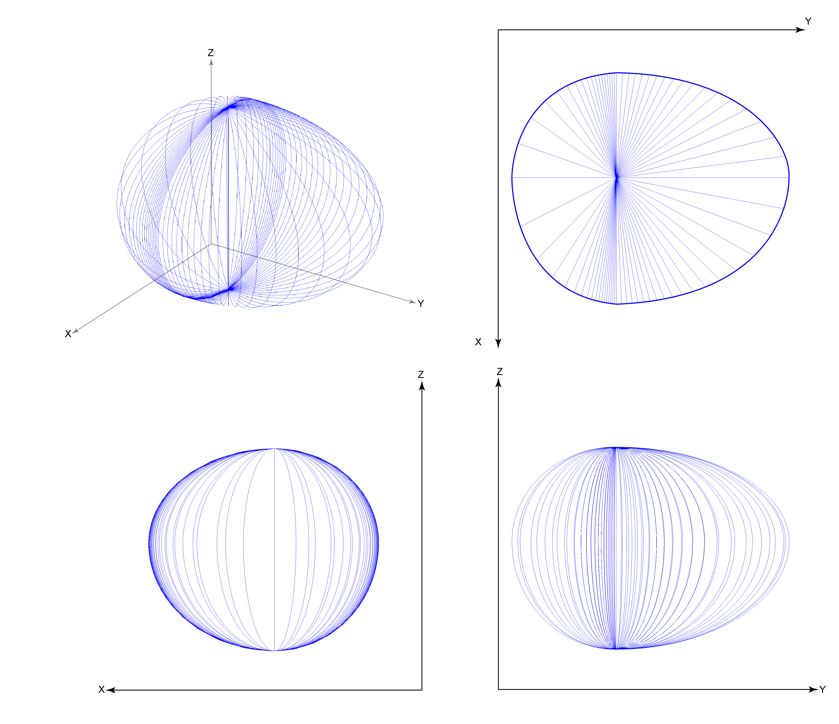
Figure 3 The surface of multiple axis ellipsoid with six semi axes in spatial coordinates X, Y, Z

From figure 3 it is clear how different values of semi axes influence the shape asymmetry of a small celestial body. Appropriate values of semi axes are determined from astronomical-geodetic and photogrammetric investigations.

The calculation of equidistant along meridians cylindrical projection of multiple axis ellipsoid with six semi axes
The equations of an equidistant along meridians cylindrical projection of tri axial ellipsoid are follows:
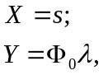 (4)
where
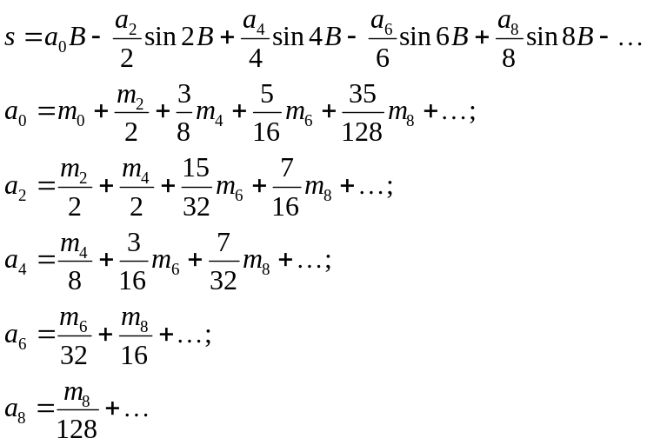 (5)

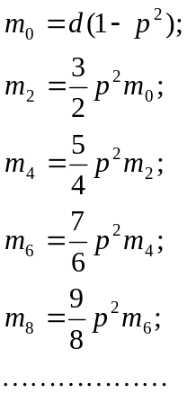 (6)

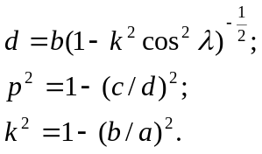 (7)

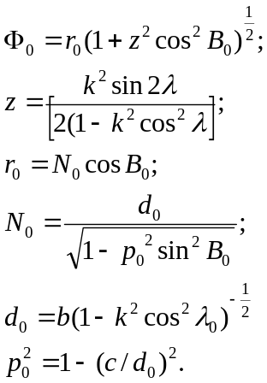 (8)

For cartographical projections of a multiple axis ellipsoid it is possible to use the equations developed for a tri axial ellipsoid but substituting different values of semi axes to change the formulas. As an example, under these conditions and from equations (4) the equidistant along meridians cylindrical projection for a multiple axis ellipsoid with six semi axes corresponding to asteroid Eros: a= 14274,9 m, b=7583,6 m, c= 6250,2 m, a'= 15804,3 m, b'= 4750,8 m, c'= 5839,6 m were calculated. The resulting cartographical grid of Eros is shown in Figure 4.
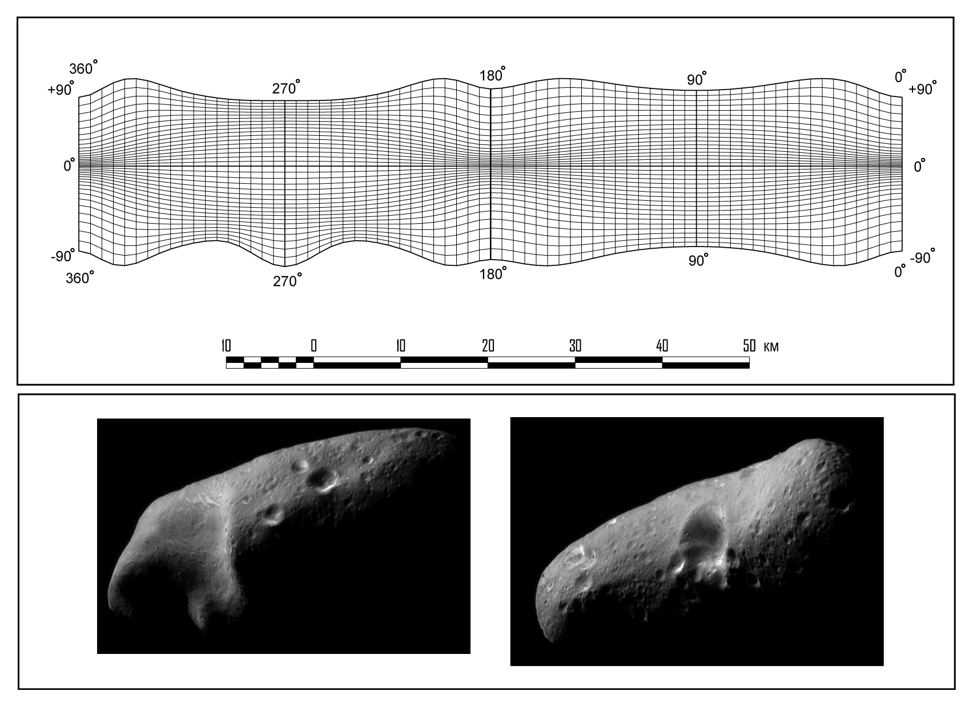
Figure 4. Cartographical grid of asteroid Eros in equidistant along meridians cylindrical projection for a multiple axis ellipsoid with six semi axes in comparison with space imagery of Eros hemispheres (The asteroid on space images is slightly rotated in comparison with its cartographical grid).
[Images from the Near Earth Asteroid Rendezvous mission, courtesy JHU-APL]

From cartographical grid it is easy to see the asymmetry in the shape of Eros. The western side from 180 axis meridian is different from the eastern side. For areas between the 180 and 360 meridians the northern part is different from the southern. This demonstrates the usefulness of the multiple axis ellipsoid for mapping of small celestial bodies.

Canadian approach

An independently developed version of this procedure was used to create a map of Jupiter’s satellite Amalthea in the unpublished Ph.D. thesis by P. Stooke at the University of Victoria. The map used only Voyager images because it was made before the Galileo mission. At the time only a simple shape had been determined from Voyager images, and it was represented as a four axis ellipsoid with axes a = 105 km, a’ = 165, b = 83 km, c = 75 km (where c is the polar axis). Figure 5 illustrates this four axis ellipsoid as two cartographic grids in orthographic projections. A map was drawn using a slightly modified version of this shape, and an azimuthal equidistant projection in two hemispheres centred on the b semi axes (Figure 6).
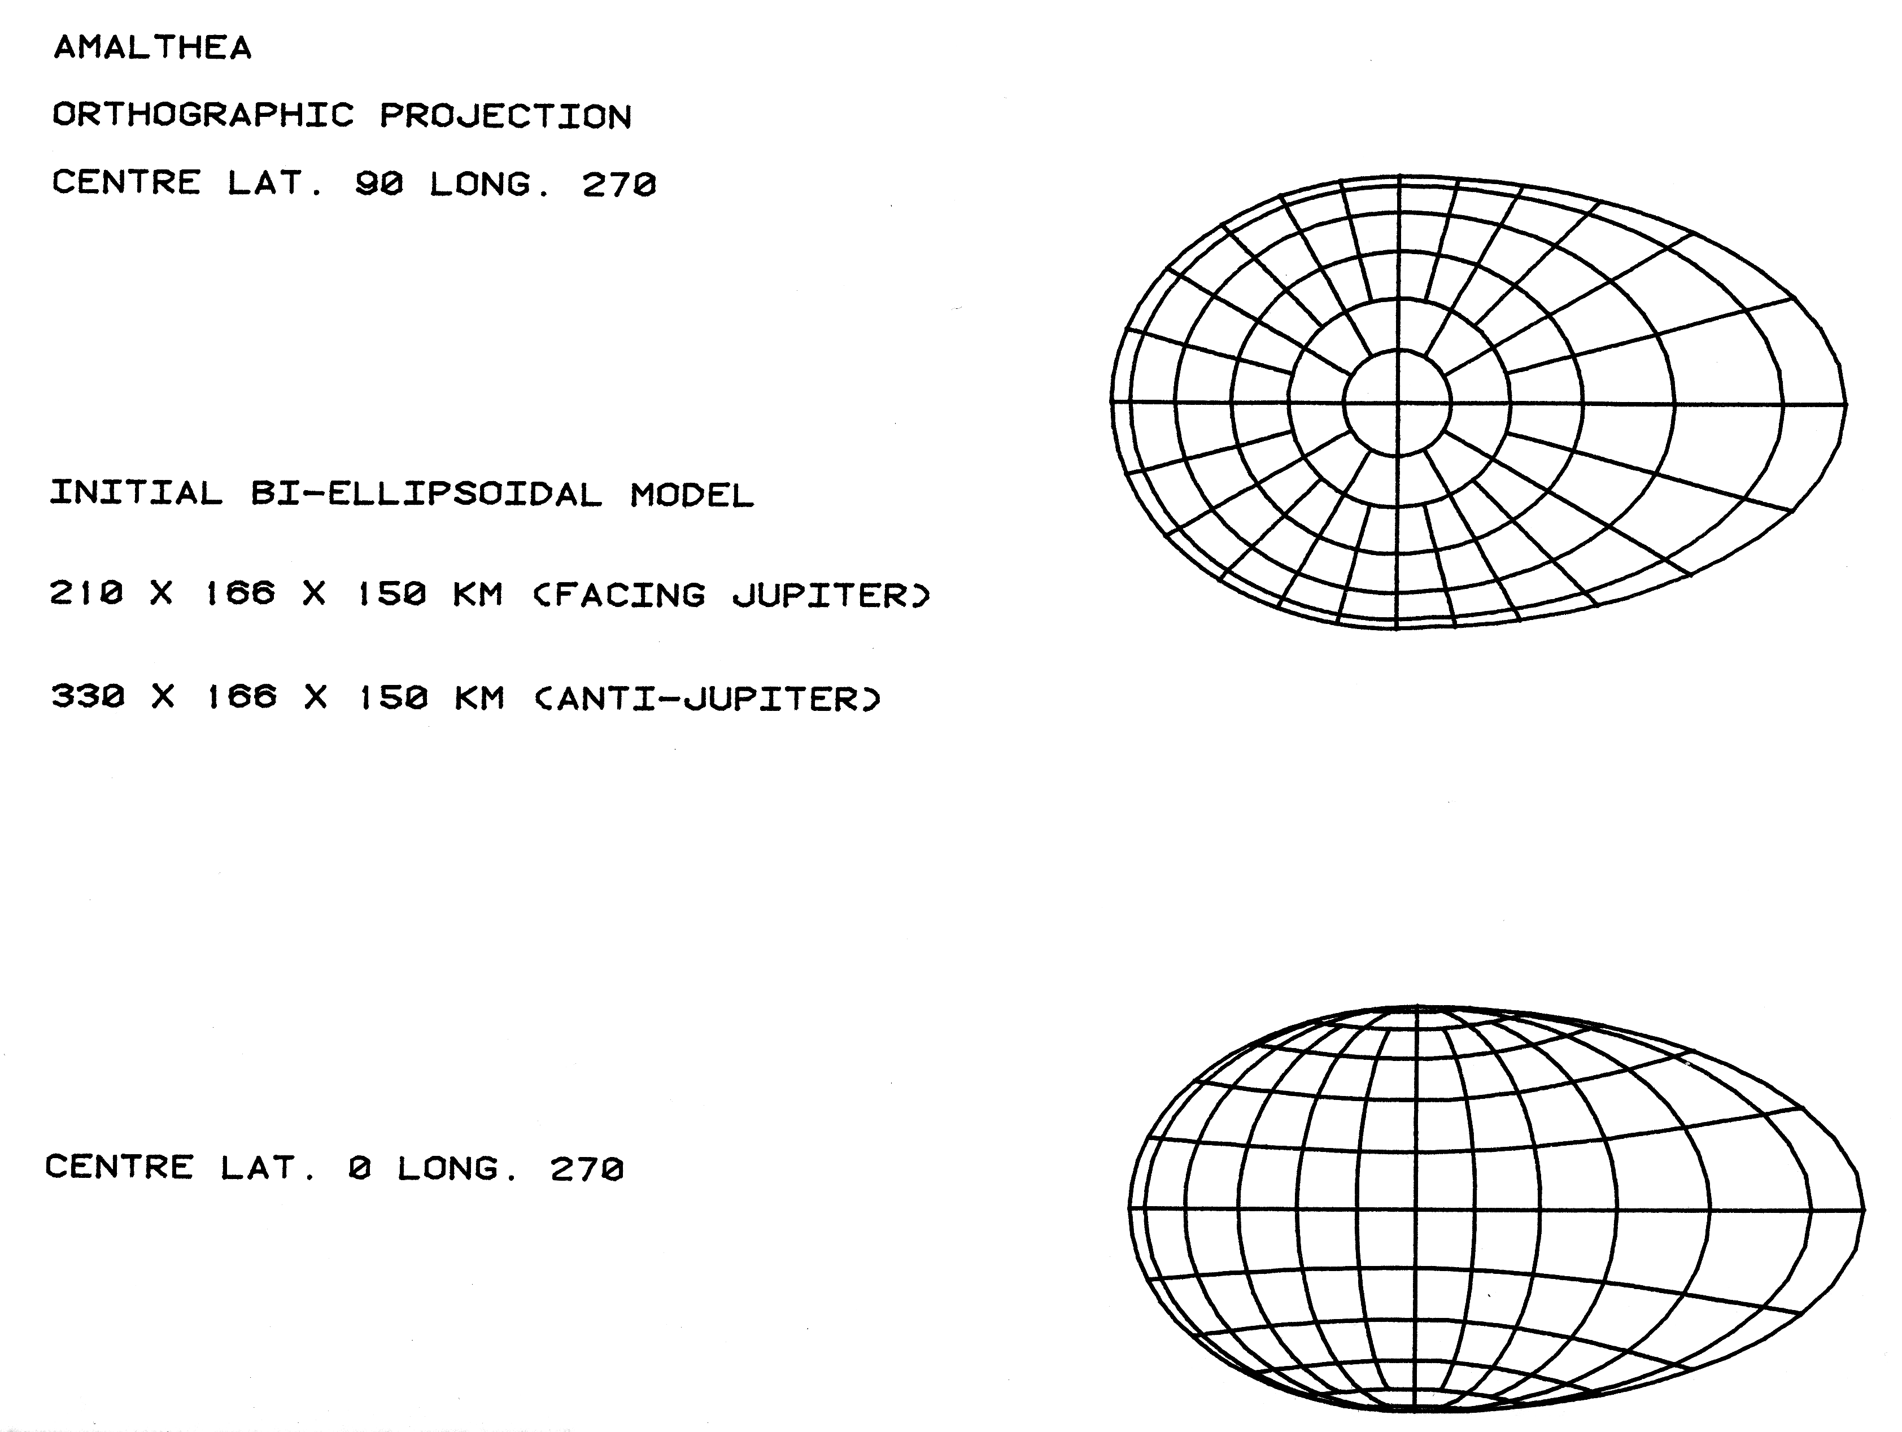
Figure 5. The four semi axes ellipsoid model of Amalthea, a satellite of Jupiter, described in the text. The more elongated end faces away from Jupiter.
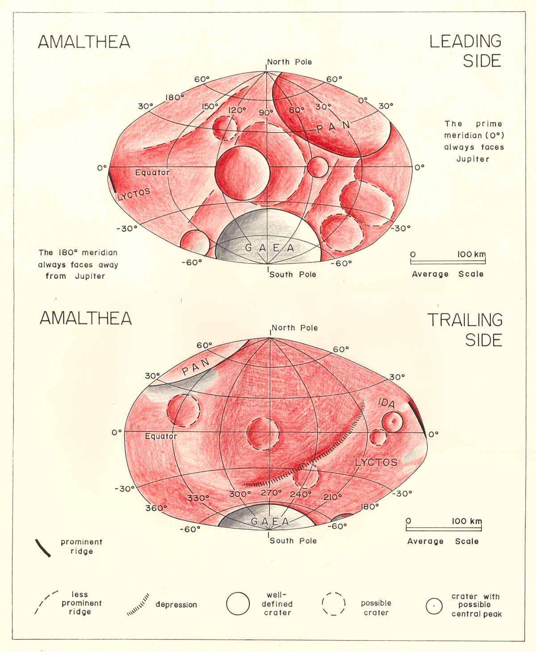
Figure 6. Map of Amalthea by P. Stooke. The shape is slightly modified from the four semi axes ellipsoid to show irregularities in the shape of the bounding meridian. The map projection is azimuthal equidistant, centred at longitudes 90 (top) and 270 (bottom).

References:
- Bugaevsky L. M. The theory of cartographical projections of regular surfaces. – Moscow.: Zlatoust publishing, 1999
- Savinykh V. P., Bugaevsky L. M., Malinnikov V. A., Reference surfaces of celestial bodies real models. The proceedings of International Scientific-Technical Conference dedicated to 225 Anniversary of MIIGAiK.. – Moscow.: MIIGAiK, 2004
- Nyrtsov M. V. Cartographical grid as method of presentation of small celestial bodies maps contents. The proceedings of International Scientific-Technical Conference dedicated to 225 Anivessary of MIIGAiK. – Moscow.: MIIGAiK, 2004
- Nyrtsov M.V. “Geographical maps of small celestial bodies: the styles and methods of presentation, the ways of use” Proceedings of the 22st International Cartographic Conference (ICC) A Coruña Spain 9-16 July 2005 “Mapping Approaches into a Changing World” CD-ROM ISBN: 0-958-46093-0
- Stooke, P. J. Cartography of Non-Spherical Worlds. Ph.D. Thesis, University of Victoria, 1988.

